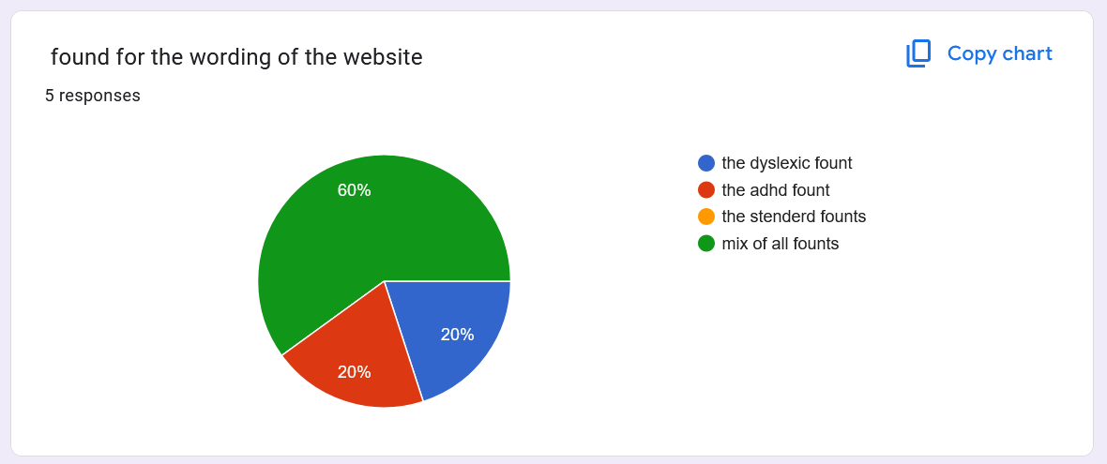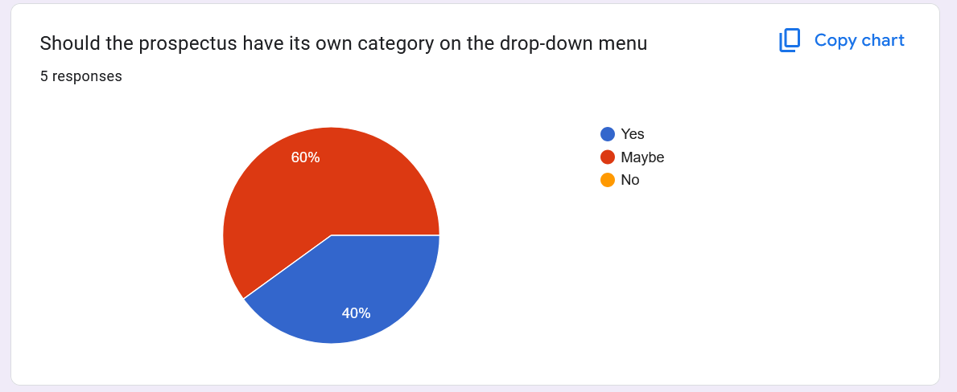

The colours:

#000043

#fffbf2

#717171

It might be a small controversy, but for a mix of ADHD and dyslexic font is

Sans-serif fonts like Arial, Verdana, and Comic Sans

But the best, according to Google, is Comic Sans

